Template for Evidence(s)
UI GreenMetric Questionnaire

University : ...
Country : ...
Web Address : …
SAMPLE
[7] Governance and Digitalization (GD)

[7.21] Written Code of Ethics that applies to university leaders, academic staff, administrative staff, and students (GD.12)

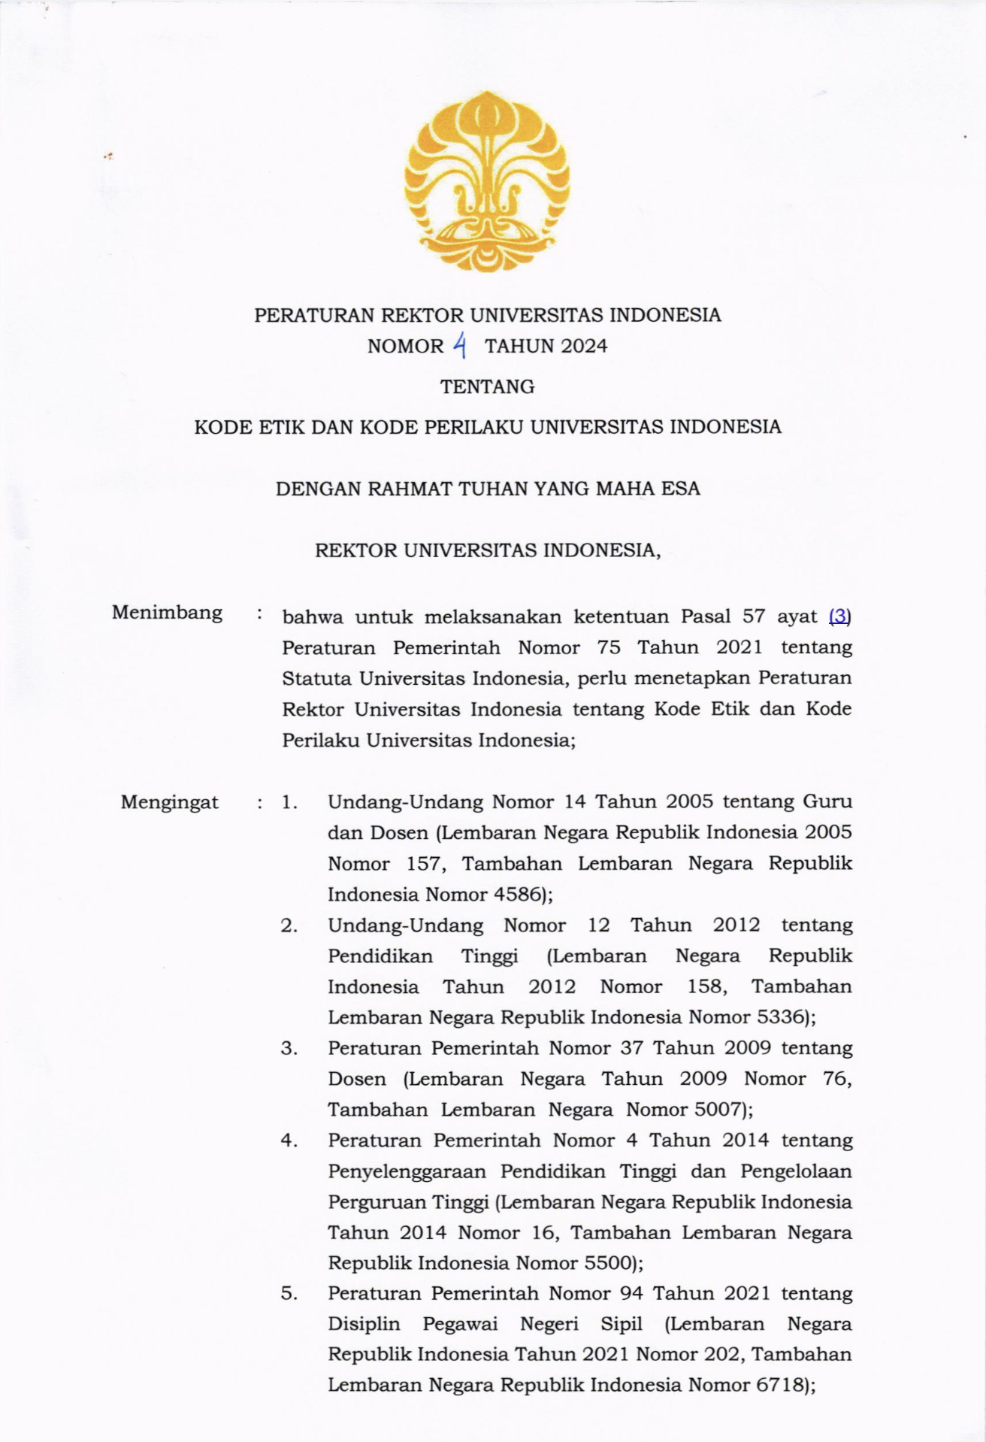
Code of Ethics rule at Universitas Indonesia through Rectors Decree No. 4 2024

Description:
(Please describe the written Code of Ethics that applies to university leaders, academic staff, administrative staff, and students)

Additional evidence link (i.e., for videos, more images, or other files that are not included in this file):
https://ppid.ui.ac.id/wp-content/uploads/2024/10/PR-2024-NO-4-Tentang-Kode-Etik-Dan-Kode-Perilaku-Universitas-Indonesia_watermark.pdf

